Digital Political Advertising During Live Sports
Platform Engagement and Advertising Performance Analysis

Introduction
Live sports events represent one of the most concentrated audience environments in modern media. Millions of viewers simultaneously watch sporting events while also interacting with digital platforms such as social media, sports applications, and streaming services. Research shows that a significant portion of sports fans engage with a second screen, typically a mobile device, during games, creating new opportunities for targeted digital advertising.
This project analyzes digital political advertising performance during live sports broadcasts by examining engagement patterns across different sports leagues, advertising platforms, and moments during games. The goal of this analysis is to identify which sports environments, platforms, and audience segments produce the strongest advertising engagement and recall.
Using a structured dataset of sports advertising metrics, this report evaluates engagement rates, click-through performance, and audience response to digital political advertisements during live sports events.

Dataset Description
The dataset used for this analysis contains advertising performance metrics collected across multiple sports leagues, digital platforms, and audience segments. Each observation represents a combination of a sport, advertising platform, game moment, and target audience demographic.
Key variables in the dataset include:
- Sport (NFL, NBA, MLB, NHL, College Football, Soccer)
- Platform (Social Media, Streaming, Sports Apps, Betting Apps, Connected TV)
- Game Moment (Pre-Game, Quarters, Halftime, Post-Game)
- State (target market)
- Audience Age Group
- Mobile Usage Percentage
- Ad Impressions
- Click-Through Rate (CTR)
- Engagement Rate
- Advertising Spend
- Ad Recall
These variables allow the analysis of how advertising engagement varies depending on the sports environment, platform type, and audience characteristics.

Dataset Description
The dataset used for this analysis contains advertising performance metrics collected across multiple sports leagues, digital platforms, and audience segments. Each observation represents a combination of a sport, advertising platform, game moment, and target audience demographic.
Key variables in the dataset include:
- Sport (NFL, NBA, MLB, NHL, College Football, Soccer)
- Platform (Social Media, Streaming, Sports Apps, Betting Apps, Connected TV)
- Game Moment (Pre-Game, Quarters, Halftime, Post-Game)
- State (target market)
- Audience Age Group
- Mobile Usage Percentage
- Ad Impressions
- Click-Through Rate (CTR)
- Engagement Rate
- Advertising Spend
- Ad Recall
These variables allow the analysis of how advertising engagement varies depending on the sports environment, platform type, and audience characteristics.

Analysis and Findings
Engagement Rate by Sport
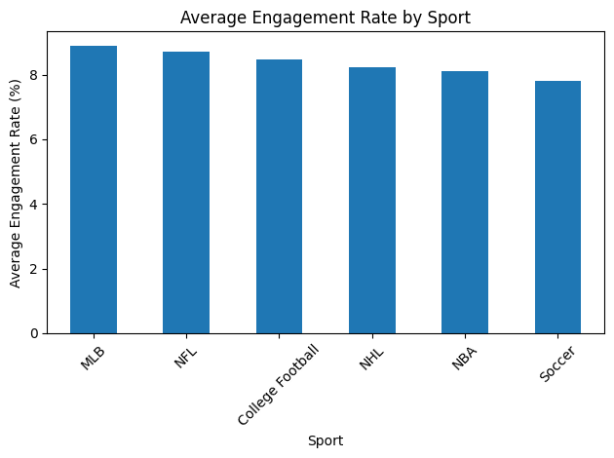
Figure 1. Average Engagement Rate by Sport
This chart illustrates the average digital advertising engagement rate across different sports leagues. The results suggest that certain sports generate stronger audience interaction with digital advertisements. High-engagement sports environments often feature highly active fan communities and increased second-screen activity during live events.
Sports with higher engagement rates may provide more effective opportunities for targeted political advertising campaigns due to greater audience interaction with mobile devices and digital platforms.

Platform Performance Analysis
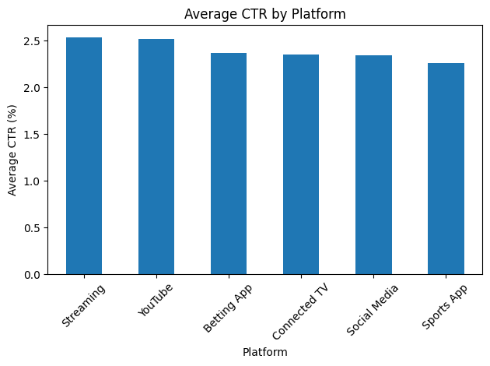
Figure 2. Average Click-Through Rate by Platform
This figure compares the average click-through rate across various advertising platforms used during live sports events. Digital platforms differ significantly in their ability to generate user interaction with advertisements.
Social media and sports applications often produce stronger engagement due to their interactive nature and real-time connection to sports content. Platforms with higher click-through rates may offer more effective channels for delivering political messaging during sporting events.

Advertising Recall by Game Moment
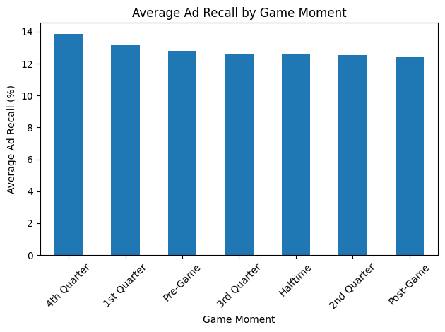
Figure 3. Ad Recall Across Different Game Moments
This visualization examines how advertising recall varies depending on when an advertisement appears during a sporting event. The analysis indicates that certain moments, such as halftime or pre-game periods, may generate stronger ad recall due to higher levels of second-screen activity and viewer attention.
Understanding these timing patterns allows campaigns to optimize advertising placement within live sports broadcasts.

Advertising Impressions by State
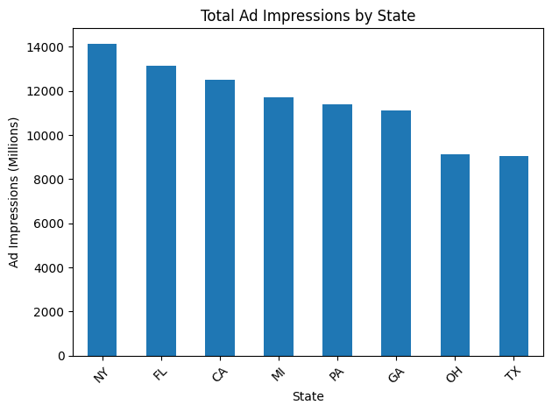
Figure 4. Total Advertising Impressions by State
This chart displays the total number of digital advertising impressions delivered across different geographic markets. Regional variation in impressions reflects differences in audience size, sports popularity, and targeted campaign investment.
Geographic targeting is an important factor in political advertising strategies because campaigns often prioritize specific states or districts based on electoral competitiveness.

Advertising Spend and Click-Through Rate Relationship
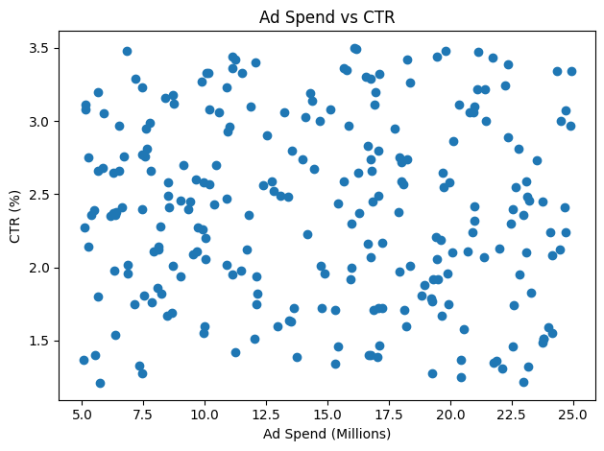
Figure 5. Relationship Between Advertising Investment and Click-Through Rate
This scatter plot analyzes the relationship between advertising spend and click-through rate. While higher advertising investment generally increases exposure, the results show that spending alone does not guarantee higher engagement. Campaign effectiveness also depends on targeting strategy, creative content, and platform selection.

Mobile Usage and Engagement Rate
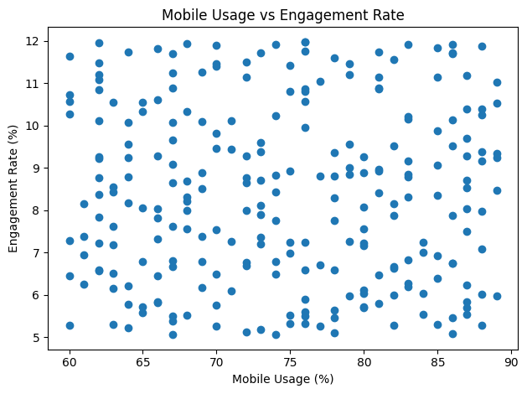
Figure 6. Mobile Usage and Audience Engagement
This figure explores the relationship between mobile device usage during live sports and advertising engagement rates. Higher mobile usage typically corresponds to stronger second-screen behavior, which increases opportunities for digital advertisements to capture viewer attention.
These findings support the importance of second-screen advertising strategies during live sports broadcasts.

Audience Engagement by Age Group
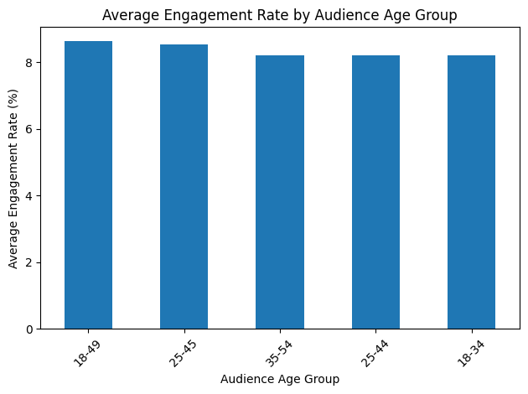
Figure 7. Average Engagement Rate by Audience Age Group
This chart analyzes the average engagement rate across different audience age groups exposed to digital political advertisements during live sports events. Audience demographics play an important role in determining how viewers interact with digital advertising content, particularly in environments where second-screen behavior is common.
The results suggest that certain age groups demonstrate higher levels of interaction with digital advertisements during live sports broadcasts. Younger audiences, particularly those between 18 and 34 years old, often exhibit higher engagement rates due to stronger social media usage and mobile device interaction during games. In contrast, older audience segments may demonstrate lower levels of interaction but still contribute to overall advertising reach.
Understanding these demographic engagement patterns allows political campaigns to tailor messaging strategies and allocate advertising budgets more efficiently toward audience segments that are most responsive to digital outreach.

Click-Through Rate by Sport and Platform
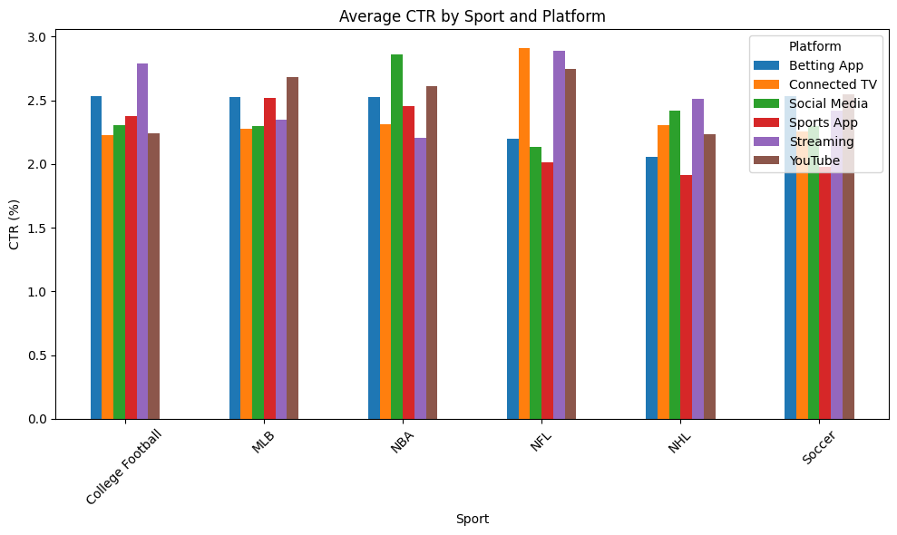
Figure 8. Average Click-Through Rate by Sport and Platform
This analysis evaluates how click-through rates vary across combinations of sports leagues and digital advertising platforms. Different sports attract audiences with distinct viewing behaviors and demographic characteristics, while advertising platforms vary in their ability to generate interaction with digital advertisements.
The results show that certain sports-platform combinations produce stronger advertising performance than others. For example, social media and sports applications often generate higher click-through rates because they allow real-time interaction with sports content and discussions. In contrast, some streaming platforms may produce lower direct interaction but still contribute to broader advertising exposure.
These findings highlight the importance of selecting both the appropriate sports environment and digital platform when designing political advertising campaigns during live sporting events.
Key Insights
The analysis highlights several important insights regarding digital political advertising during live sports events.
First, engagement rates vary significantly across sports leagues, indicating that certain sports environments may provide more effective opportunities for advertising campaigns. Sports with highly engaged fan bases tend to generate stronger digital interaction.
Second, advertising platform choice plays a major role in campaign performance. Social media and sports applications frequently produce higher click-through rates compared to traditional streaming or display formats.
Third, the timing of advertisements during games significantly influences audience response. Moments such as halftime or pre-game periods appear to generate stronger advertising recall due to increased second-screen activity.
Finally, mobile device usage strongly correlates with advertising engagement, reinforcing the importance of second-screen strategies for political advertising during live sporting events.

Strategic Recommendations
Based on the analysis, several strategic recommendations can improve the effectiveness of political advertising campaigns during live sports events.
Campaigns should prioritize platforms with higher engagement rates, particularly social media and sports applications that support real-time audience interaction.
Advertising delivery should also be optimized around key moments in sports broadcasts, such as halftime or pre-game periods, when second-screen engagement peaks.
Additionally, campaigns should focus on geographic markets where sports audiences align with key voting demographics, allowing for more targeted and efficient advertising investment.

Conclusion
This analysis explored the effectiveness of digital political advertising during live sports events by examining engagement patterns across sports leagues, advertising platforms, audience demographics, and game moments. The results highlight how live sports environments create unique opportunities for digital advertising due to high audience engagement and widespread second-screen behavior.
The findings indicate that advertising performance varies significantly depending on the sport, platform, and timing of advertisements within a game. Certain sports environments generate stronger engagement levels, while digital platforms such as social media and sports applications consistently produce higher click-through rates compared to other advertising channels. These platforms enable real-time interaction with sports content, making them particularly effective for reaching highly engaged audiences.
The analysis also shows that audience demographics influence engagement patterns. Younger age groups generally demonstrate higher levels of interaction with digital advertisements, reflecting stronger mobile device usage and social media activity during live sports broadcasts. In addition, advertising timing plays an important role in campaign performance, as moments such as halftime and pre-game periods often generate higher levels of audience attention and second-screen activity.
Overall, the results suggest that successful digital political advertising strategies during live sports events require a combination of platform selection, audience targeting, and strategic ad timing. By leveraging data-driven insights into audience behavior, campaigns can optimize advertising placement and allocate resources more effectively.
As sports audiences continue to engage with multiple digital platforms while watching live events, second-screen advertising strategies will likely become an increasingly important component of modern political communication and digital marketing efforts.

